Philips AWS SSO user details across the phht groups.

* Login to the AWS console - <https://atosuk-sso.awsapps.com/start/#/>
* You will see the below SSO account details, Click on management console.

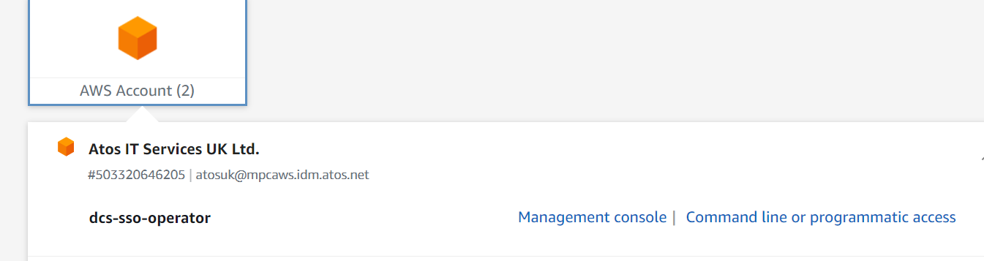

* In the search box type for SSO and click on AWS single sign on as shown below.

SSO region is us-east-1

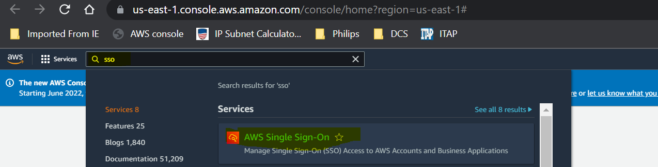

* Click on the groups as show below.

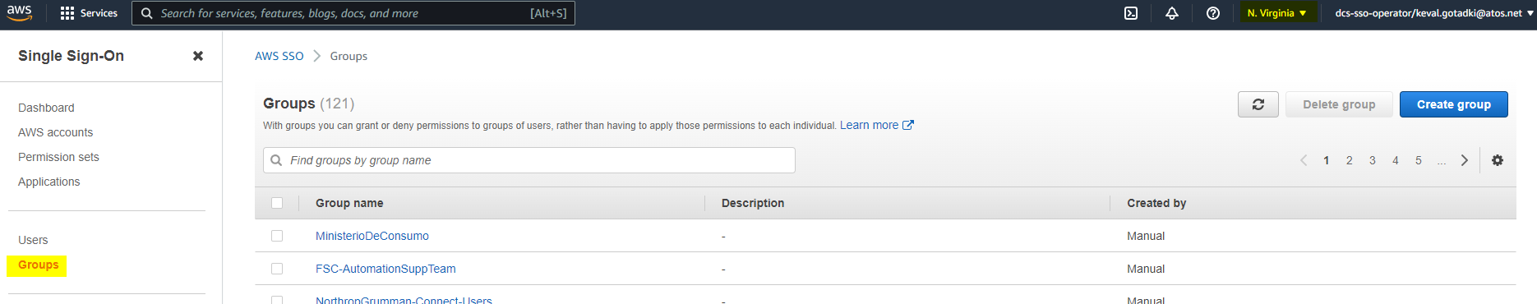

* In the search box type phht and for all the 7 groups get the IAM user assigned to it and copy in a excel sheet.

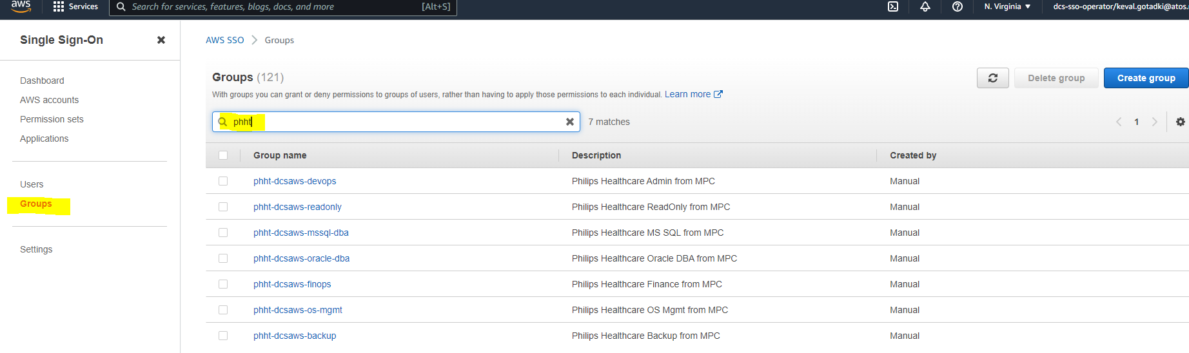

* Click on the first group phht-dcs-aws-devops copy the details.

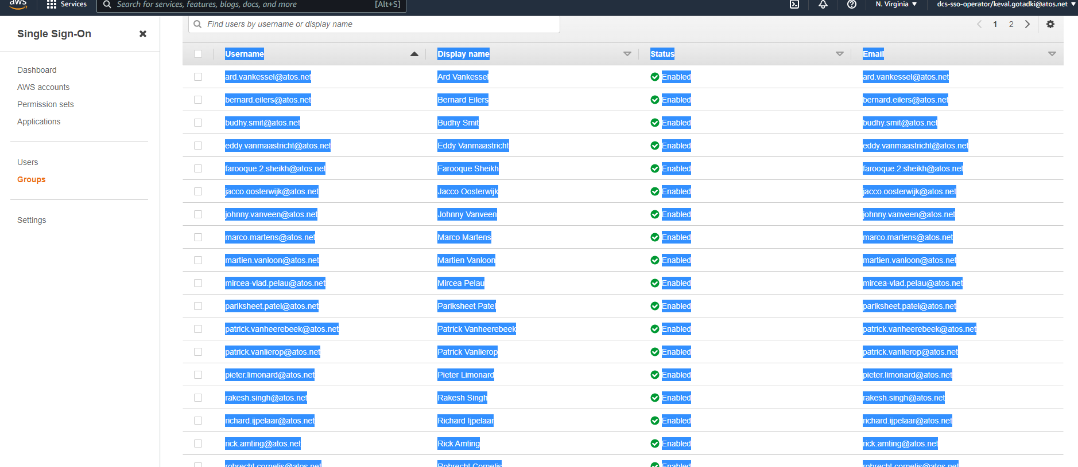

* Perform the same steps for all the 7 groups, get the IAM user and copy in the excel sheet as per the groups. Please find the attached sheet for reference.

